Stockton-Delta Amateur Radio Club
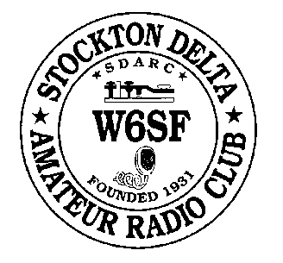
AN ARRL AFFILIATED CLUB
WWW.W6SF.ORG

NOVEMBER / DECEMBER 2015
____________________________________________________________________________

Welcome to the Stockton-Delta Amateur Radio Club

Two Months of club news, same low price!

PRESIDENT’S MESSAGE – W6COB

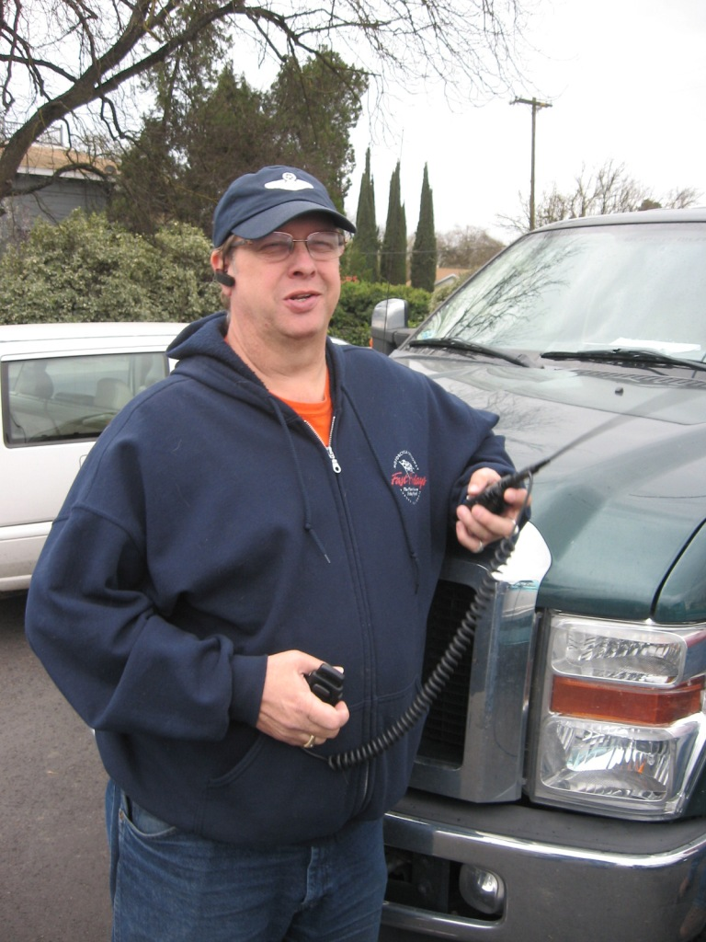
WOW – Has it been a year already? Time sure flies when you’re having fun. We had a lot of fun last year together… The Bike Ride in Linden started us off in February; March of Dimes walk and Delta Century in April; Museum Ships Weekend and Field Day in June; Ham Cram and Elmer University in August; CQP in October and Turkey Trot on Thanksgiving morning. It sure was cold out. But it was great to see the participation and enthusiasm of the membership for being in the cold at 6:30 AM. Anyone notice the club emblem on the back of the Run Against Hunger commemorative long sleeve shirt? Stockton-Delta Amateur Radio Club is right in the middle of all the sponsors. That’s pretty cool!

Make sure you’re coming to the December Meeting / Christmas Party. I’ll be passing the gavel to Dan KI6FTT who takes over as President on January 1st. I’ll be around – that “member at large” seat will likely have my name on it next year….

See you at the Christmas Dinner on December 10th!

73,

Chuck, W6COB


DECEMBER MEETING / CHRISTMAS DINNER
STOCKTON-DELTA AMATEUR RADIO CLUB
THURSDAY DECEMBER 10TH 2015
CHUCK’ ST PACIFIC AVE BOWL
6:30 PM

QST QST QST All members and their guests are invited to attend the Annual Christmas Dinner Meeting of the Stockton-Delta Amateur Radio Club on THURSDAY DECEMBER 10TH . The location for the meeting / Christmas Dinner will be at Chuck’s at Pacific Ave Bowl, Pacific Ave at Swain Rd. The Meeting will start at 6:30 with Dinner served by 7:00 PM

There is a full service banquet room where we will be having our Christmas Dinner. Dinner will be served Buffet Style with a serve yourself Salad Bar, Mixed Vegetables, Chicken Dish, Tri-Tip, Potatoes and Pasta…. Dinner will be between $15 and $20 per person including tax, drinks, tip and a $2 cover charge for the room rental. Check the website for final pricing on Monday November 30th and to pre-register. We ask you please pre-register so that there will be enough food on hand for everyone.

Members who wish to come early and bowl a few games may do so at the Bowling Alley. Pacific Bowl is offering free shoe rental for bowlers before the event. League bowling will prevent bowling after the meeting. No host cocktails are served in the bar area adjacent to the banquet room before, during and after the party.

Raffle! The membership voted to bring back the dual-band mobile as a prize this year. We have purchased a B-TECH Mini Mobile from Amazon and it will be available at the Christmas Dinner for one lucky winner. This is a 2nd generation mini mobile from Beofeng and has received very good reviews.
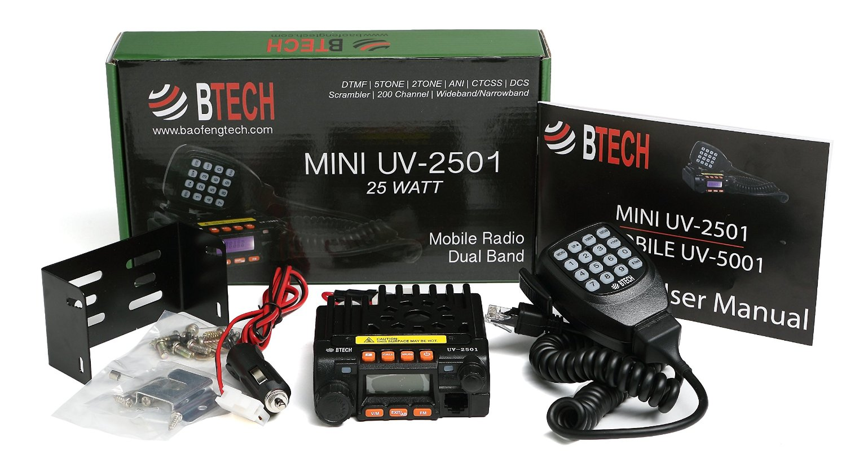

We will also have Gift Certificates from Ham Radio Outlet and a number of other prizes to raffle.



Our program will include a presentation in pictures of 2015 club events in review and the traditional ‘pass of the gavel’ between outgoing President Chuck W6COB and 2016 President Dan KI6FTT.

If you are need of transportation to and from the meeting, please contact Paul, N6KZW or John, NZ6Q and we will arrange transportation assistance for you.

DECEMBER HAM CRAM

STOCKTON-DELTA AMATEUR RADIO CLUB
COMCAST BUILDING – STOCKTON
6505 TAM O’SHANTER DRIVE
SATURDAY DECEMBER 12TH , 2015
DOORS OPEN 8:00 AM

“Get Your License in a Saturday” is the perfect solution to getting your ham radio license in today’s busy world. No tedious preliminary home study. No long, boring once-a-week classes. You attend for just one day, 8:00 AM to 4:00 PM, and you’re done.
Thousands of men and women, aged 16 to 90, have succeeded in getting their Amateur Radio license this way. HamCram is not a class. It is guided study — six 50-minute reading sessions with 10-minute breaks and a 60-minute break for lunch. The FCC exam is given at the end of the day.

Testing-Only Also Available
The FCC exam session at 3 PM is open to the public. We administer all levels of amateur radio exams: Technician, General, and Extra class. One need not attend the HamCram just to take an exam. The cost for the exam-only is the officially-prescribed fee of $15.00. If you’ve paid to attend the HamCram, the exam fee is included.

Sign up for the next HamCram clicking the link here.

THE ELMER UNIVERSITY – FOR NEW HAMS
SATURDAY DECEMBER 12TH 2015
CLASSES START AT 9:00 AM

Our instructors are preparing to roll out the 2nd session of Elmer University with several venues that will give new hams both classroom knowledge and practical experiences. We are planning to be on the air for
Classes and presentations include:

Anderson Power Poles and practical antenna theory ………………………………..Bob N6TCE
Programming your HTs………………………………………… Eric W6INP & Cecil KK6QXQ
HF Operations ………………………………………………………………………Bob K6DGQ
Nets, Procedures and Process….....……………………………..............Bill AE6J & Ed N6XMA
EmComm …………………………………………………………………………. Mike K6MDS
HamSpeak “How to Not Sound like a NewBie” ……………………….Bill AE6J & John NZ6Q

On the air practice during the ARRL 10-meter Contest

There opportunity to learn more about this great hobby is right here. Sign up today! And bring a new ham friend!

SIGN UP FOR ELMERING SESSIONS HERE.

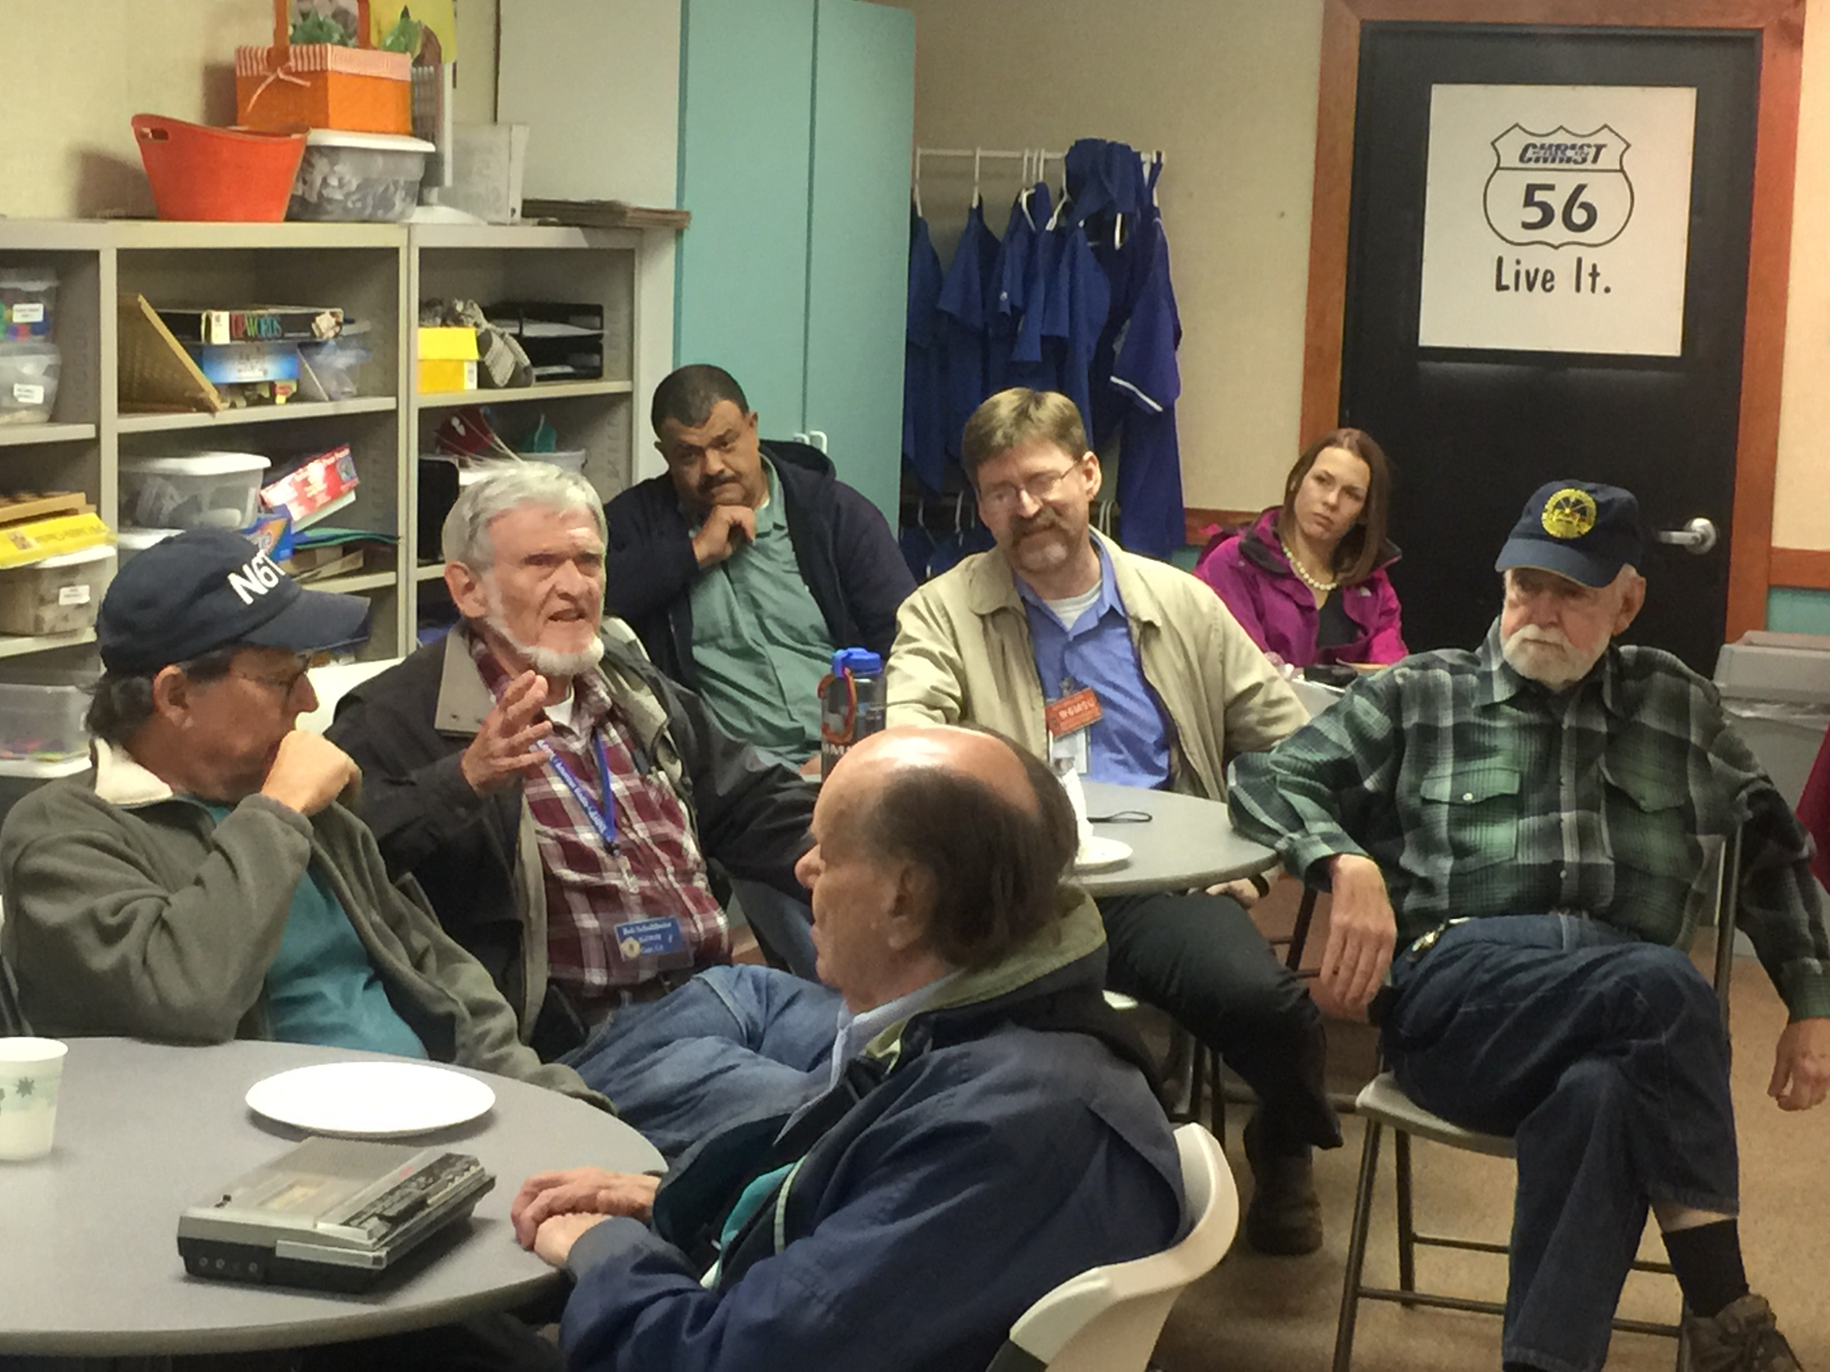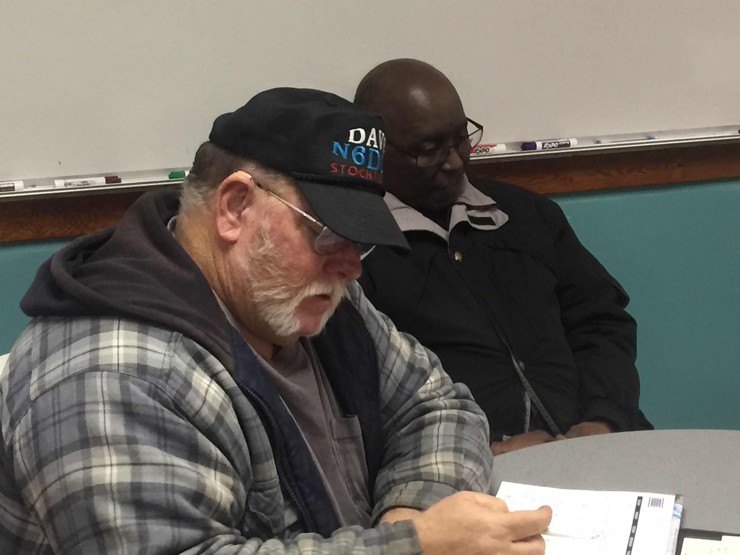

CLUB MEETING REPORT
November 2015
Bear Creek Community Church

The November meeting was called to order at 19:30 hours by President Chuck W6COB. There were several new faces in attendance so a brief introduction around the room was called.

A BIG THANK YOU to Scott KK6VYP who hosted Pizza for the meeting. It was quite delicious!

Dave N6LHL reported that the bank account was healthy at about $5900 (sorry I did not write down the exact amount) and a few bills had been paid for putting together the GOTA station.

John NZ6Q gave a report on upcoming Christmas Party and the membership voted to hold the annual gathering at Chuck’s on Pacific Ave at Pacific Bowl. There is a very nice banquet room between the restaurant and the bar (also important). The membership voted to approve the $100 room rental fee with a $2 per person assessment to be added onto the price of the dinner. Dave N6LHL agreed to make it to the Bowling Alley to pay for the rental By December 1st and will make sure that those in attendance pay as they enter.

The membership approved the purchase of a B-Tech Mini Dual Bander and two additional gift certificates from HRO to be offered as Door Prizes for the event.

The election of officers for 2016 was held. Dan KI6FTT was elected President for 2016. Guy W6MSU was elected Vice President after a “run-off” tie breaker vote with Charlie WB6NVB. Dave N6LHL was unopposed and re-elected Treasurer. Eric W6INP retained his seat as Secretary for another term.

While votes were being counted, John NZ6Q gave a short report on the HamCram from October with 11 newly licensed Technicians, and a General Upgrade. He also presented plans for the Elmer University coming on Saturday December 12th.

The meeting was adjourned at 20:45 hours. Our December Meeting will be the Christmas Dinner celebrated on December 10th at 6:30PM at Chuck’s on Pacific Ave.

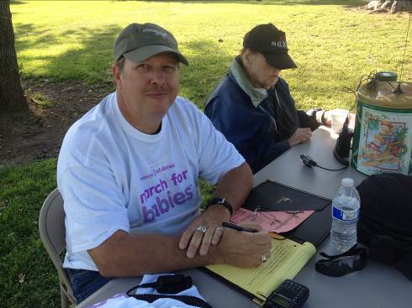

MONDAY NIGHT NET CONTROL
OPERATOR’S SCHEDULE FOR
DECEMBER – JANUARY

The club holds a weekly net every Monday night beginning at 8:00PM on the W6SF Repeaters on 147.165Mhz VHF and 444.250Mhz UHF. Club Repeater information is listed at the end of
the newsletter.

We need more Net Control Operators! If you would like to volunteer, please contact Dave N6LHL. This is a great opportunity to improve your operating skill in a “minimal” pressure environment. The Net Control Script is available on the club website at….

http://www.w6sf.org/netcontrolscript.html

If you have a conflict, please contact Dave N6LHL as soon as possible in order to secure a replacement.

November 30th Guy, W6MSU January 4th Guy, W6MSU
December 7th Paul, N6KZW January 11th Paul, N6KZW
December 14th Charlie, WB6NVB January 18th Charlie, WB6NVB
December 21st Eric, W6INP January 25th Eric, W6INP
December 28th Dave, N6LHL February 1st Dave, N6LHL



OCTOBER 15, 2015 at 10:15 AM

Millions of people worldwide will practice how to “Drop, Cover and Hold” at 10:15AM on October 15th.

The Stockton-Delta Amateur Radio Club has participated in this drill for several years with check-in numbers rivaling larger cities like Sacramento and Fresno. The plan is to call a directed net on the W6SF 147.165 repeater and take check-ins from around the city and county. Participating stations should be prepared to check-in with their call sign, location and radio capabilities.

Plan now. If you’re retired, mark the date and time on a calendar and remember to check in. If you’re working, ask now for the opportunity to carry your HT that day and take 10 minutes to check into the net. Your employer can participate in the “Drop, Cover and Hold” drill and get credit at the Great California Shakeout website.



Visit www.shakeout.org for more information

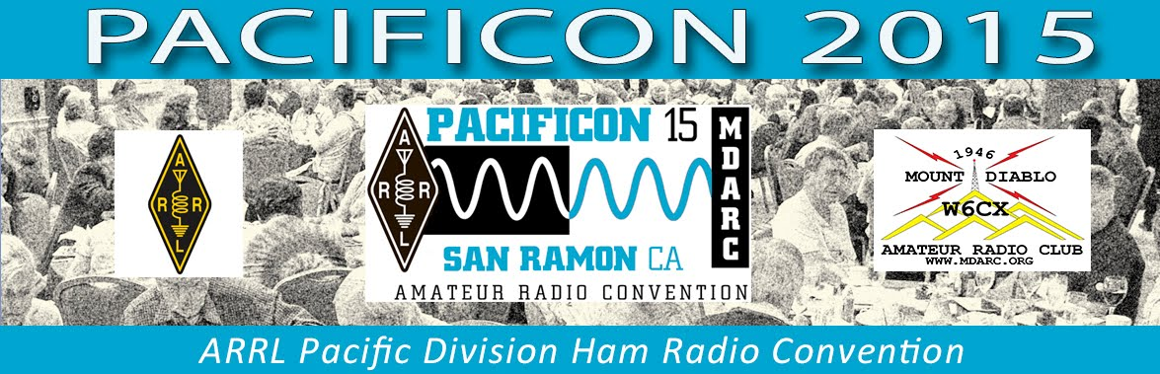

OCTOBER 16 - 18, 2015
SAN RAMON VALLEY MARRIOTT

Pacificon gives you three great days of activities for one low cost:

A full slate of outstanding Forum presentations about a wide range of amateur radio topics, a large Vendor Expo filled with exciting products and exhibits, an outdoor Swap Meet, great QRP activities, a Youth Forum and great Youth Activities including electronics kit building and soldering classes, a One Day License Prep Class to prepare you to pass the amateur radio Technician license examination and get your first amateur radio license, a chance to hear about and discuss important national amateur radio issues with top ARRL leaders, a chance to win radios and other great prizes throughout the convention, and perhaps the best part - a chance to interact and share information with lots of other amateur radio enthusiasts to further (or begin) your own knowledge and to advance the hobby.

Click HERE to REGISTER for PACIFICON 2015

A HAM’S CALENDAR

October 3 - 4 , 2015 – 50th Running of the California QSO Party. www.cqp.org
October 8th , 2015 – Stockton-Delta ARC Club Meeting – Meeting will be at 7:30PM at the Bear Creek Community Church, 11171 N Lower Sacramento Rd, Stockton.
October 10th, 2015 – Stockton-Delta ARC HamCram – Doors open at 8:00AM for HamCram attendees. Located at the Comcast Building, 6505 Tam O Shanter Dr, Stockton Test Session only starts at 2:30PM www.w6sf.org/hamcram.html
October 10th , 2015 – Elmer University – The October Elmer University has been cancelled.
October 15th , 2015 – Great Shake-out Earthquake Drill www.shakeout.org
October 16th – 18th, 2015 – Pacific Division Convention (PacificCon2015) – San Ramon Marriott Hotel, Sponsor: Mount Diablo Amateur Radio Club, Website: http://www.pacificon.org
October 19th – 23rd, 2015 – School Club Round-up Fall Term, from 1300 UTC Monday through 2359 UTC Friday. http://www.arrl.org/school-club-roundup
October 24th – 25th, 2015 – CQ World-Wide DX Contest, from 0000 UTC Saturday to 2359 UTC Sunday. http://www.cqww.org

+++++++++++++++++++++++++++++++++++++++++++++++++++++++++++++++++++++++
Do you have any suggestions, comments or concerns? We want to hear from you.
Do you have an idea that we, as a club can all benefit from? Let us hear about it.
Do you have any topic for discussion that YOU could and would contribute to the club?
We want to hear from YOU! To submit articles for the monthly newsletter, email the editor at john@litz.com

W6SF CLUB INFORMATION

MEETINGS: Regular meetings are held on the second Thursday of each month at the Bear Creek Community Church, 11171 Lower Sacramento Road, just north or Eight Mile Road. Members, guests, and people having an interest in Amateur Radio are invited to attend. The next meeting is scheduled for Thursday September 10th at 7:30PM.

WEEKLY NETS: Held each Monday evening at 2000hrs on 147.165+ PL 107.2 Hz and 442.250 + PL 107.2 Members and visitors are invited to check in. There is also an unofficial get together on Thursday evenings (except meeting night) at 7:30pm on 28.457. Amateurs with the proper license are encouraged to participate.

CLUB REPEATERS: Located in the Sierra at 2500 feet, the club repeater covers the southern Sacramento and Northern San Joaquin Valleys. The call sign is W6SF, and can be heard on 147.165+Mhz with a PL tone of 107.2 Hz. From the same site, the club also operates a 440MHZ repeater at 442.250 + with a PL of 107.2 Hz.

The club also operates a UHF repeater located in downtown Stockton 444.575MHz + with a PL 107.2Hz. Coverage includes the Stockton area as well as parts of Lodi, Manteca, Tracy and Ripon.

CLUB SIMPLEX FX: 147.51 MHz.

CLUB WEBSITE: http://www.w6sf.org

2015 CLUB OFFICERS & LEADERSHIP:

President: W6COB, Chuck O’Banion ncrmc@pacbell.net
Vice President: WB6NVB, Charlie Johnson wb6nvb@arrl.net
Treasurer: N6LHL, David Hardwick n6lhl@softcom.net
Secretary: W6INP, Eric Chapa perrla1@aol.com
Member At Large: N6KZW, Paul Engleman n6kzw@sbcglobal.net
Call Sign Trustee: AA6K, Shirl Rose rosesl@prodigy.net
Repeater Trustee: KD6FVA, John Kester jbkester@att.net
Membership Chairman open
Newsletter Editor NZ6Q, John Litz john@litz.com

CLUB DUES:

$20 SINGLE and $30 FAMILY
Stockton-Delta Amateur Radio Club, P.O. BOX 690271, STOCKTON, CA 95269‐0271

We thank you for your continued support!

